**Minute writing conventions**

Minutes should be written in such a way that a person not in attendance at the meeting can follow the decisions made as minutes are read by a variety of individuals and groups.

The following are key points to take on board when writing more formal minutes.

* Always write minutes in reported speech which is usually written in past tense
* Use verbs such as ‘*would’* rather than ‘will’ and ‘*should’* rather than ‘shall’ to denote future action’; e.g. “The Chair *would* amend the report in light of the points raised”.
* Be conscious of how time is reported in minutes e.g. use *‘the following week’* instead of ‘next week’; e.g. “The Chair would amend the report in light of the points raised and distribute it to the Committee *the following week*”
* The Committee is singular not plural.
* In most cases the Committee as a collective should be used: “The Committee noted that...”
* List members in the attendance table using titles only where they are earned or honorary e.g. Dr, Professor, but do not use Mr, Mrs, Ms etc.
* List apologies in the relevant table, do not write a minute about apologies.
* Ensure that those in attendance are listed as such under a separate heading to avoid confusion with board members
* For approval of minutes use “The Board **confirmed** the minutes of the meeting held on 15 February 2013.” No need to say “as a true and accurate record” etc.  If amendments are required either use “subject to” and state the amendment if it’s straightforward or “subject to the following amendments” and list if there are a few.
* When referring to a member of staff in the minutes do not refer to them by name, but by role except in the attendance section in the header of Minutes and in any action e.g. the “Director of AQS” not “Michael Wing”
* When referring to a student in the minutes again use their role not their name, e.g. “Vice President Academic” or “Year 1 Student Voice Leader”
* Start each minute with “The Committee **considered/received**”then continue with the item.Use the following in the following circumstances:
  + **Considered** where the Board is to make either a decision or endorse a decision or recommend approval.
  + **Received** where the item is for information or discussion but no decision to result apart from the paper being noted. For example ‘the Board received the summary of regulations’.
* For decisions use **approved,** but ensure that it is a decision that the Board can make.
* For information received use **noted.**
* When assigning actions, this should be in bold at the end of the relevant minute and list the role of the individual to whom action is assigned rather than their name.

<http://www.mdx.ac.uk/Assets/guidance9i.doc> 2013/14

**Useful words**

The following are examples of words to describe in a set of minutes how someone has said something in a meeting. This list is not exhaustive and you can use others:

| admitted | Disclosed | Noted | Reported |
| --- | --- | --- | --- |
| Advised | Expressed | Ordered | Requested |
| Affirmed | Enquired | Promised | Said |
| Agreed | Established | Proposed | Stated |
| Announced | Facilitated | Queried | Suggested |
| Apologised | Hoped | Questioned | Told |
| Asked | Informed | Recommended | Urged |
| Believed | Invited | Recounted | Voiced |
| Claimed | Justified | Remarked | Wanted to know |
| Commended | Maintained | Reminded | Warned |
| Conveyed | Mooted | Replied | Wondered |

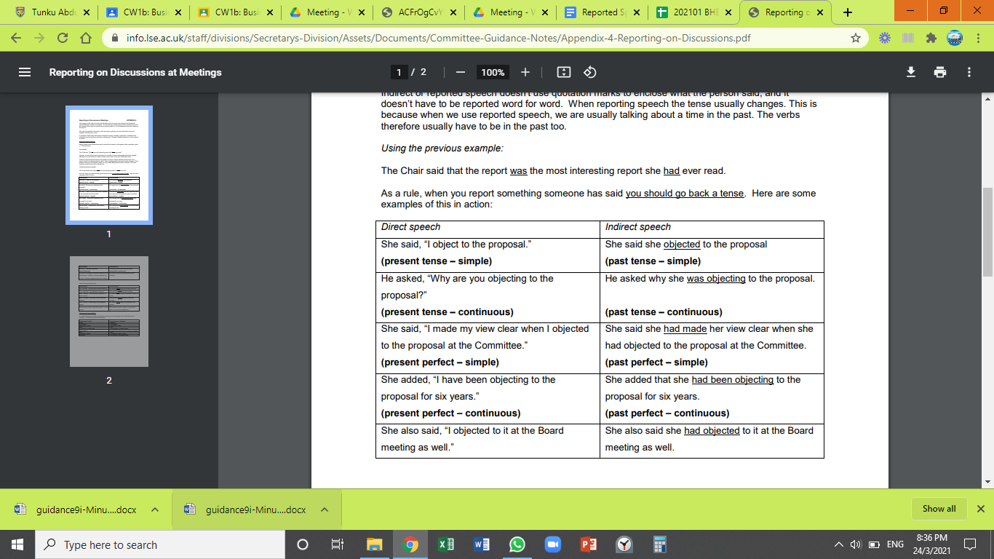(Adopted from: https://info.lse.ac.uk)